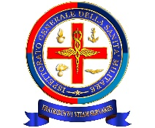
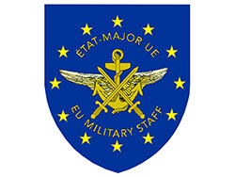

SYMPOSIUM “MEDICAL SUPPORT TO EU COMMON SECURITY AND DEFENCE POLICY (CSDP) OPERATIONS”
CASA DELL’ AVIATORE, ROME, 7-9 JUNE 2016
Joining Form
General info
First Name |  | Family Name
Rank/ Title |  | Organisation
Position |  | ID/ Passport number
email
Estimated arrival date |  | Estimated departure date

☐ I will attend the preparatory workshop on 7th June (military medical experts and observes only)
☐ I will attend the plenary sessions on 8th June
☐ I will attend the plenary sessions on 9th June

Social events
I will attend the following:
☐ Hosted Lunch on 7th June ☐ Hosted Icebreaker on 7th June
☐ Hosted Lunch on 8th June ☐ Hosted Lunch on 9th June

Accommodation (pre-booking only for forms received before 5 May 16)
☐ Book on my behalf a Choose an item. room at “’Casa dell Aviatore”’ main site
☐ Book on my behalf a Choose an item. room at the Annex in Via Spallanzani

Please, return the filled form NLT 31 May 2016 to internazionale@igesan.difesa.it , copy to giuseppe.azzena@eda.europa.eu and Doina.BARAR@eeas.europa.eu

